

**JOSÉ RIZAL UNIVERSITY**

**College Division**

**Gamified Mathematics Learning through a Web Development for Grade 1 Student at Jose Rizal University**

**A Project Study**

**Presented to the Faculty of the**

**College of Computer Studies and Engineering**

In Partial Fulfillment of the Requirements

for the Degree of Bachelor of Science in Information Technology

by

**Christian King Maranan**

**John Michael S. Montes**

**Danielito U. Bernardo**

**Kian Andrei Visaya**

2nd Semester, SY 2024-2025



**JOSÉ RIZAL UNIVERSITY**

**College Division**

**APPROVAL SHEET**

The thesis, entitled: **Gamified Mathematics Learning through a Web Development for Grade 1 Student at Jose Rizal University** prepared and submitted by **Christian King Maranan, John Michael S. Montes, Danielito U. Bernardo, and Kian Andrei Visaya**, in partial fulfillment of the requirements for the degree of **Bachelor of Science in Information Technology** has been examined and recommended for acceptance and approval for Oral Presentation

**RONEL JARON BILOG**

Research Adviser

Approved by the PANEL OF EXAMINERS on Oral Defense on 05/24/2024 with a grade of ______.

Date

Grade

**SHARMAINE JUSTYNE R. MAGLAPUZ, MIT**

Chair

**VIRGINIA B. LOYOLA, MBA, MIT EDELITA LORICO, MBA, MIT**

Member Member

**SHARMAINE JUSTYNE R. MAGLAPUZ, MIT**

*Department Chair, Information Technology*

Accepted and approved in partial fulfillment of the requirements for the degree of **Bachelor of Science in Information Technology.**

**LIZA R. REYES, MENGG-CPE**

Dean, Computer Studies and Engineering



**JOSÉ RIZAL UNIVERSITY**

**College Division**

**CERTIFICATE OF ORIGINALITY**

We hereby declare that the thesis entitled, **Gamified Mathematics Learning through a Web Development for Grade 1 Student at Jose Rizal University** is our own original work carried out as Bachelor’s student at Jose Rizal University except to the extent that assistance from others in the thesis’ design and conception or in style, presentation and linguistic expression are duly acknowledged.

All sources used for the thesis have been fully and properly cited. It contains no material which to a substantial extent has been accepted for the award of any other degree at JRU or any other educational institution, except where due acknowledgement is made in the thesis.









**Visaya, Kian Andrei Montes, John Michael S.**

**Maranan, Christian King Bernardo, Danielito U.**

**05/06/2022**

**ABSTRACT**

**Title: Gamified Mathematics Learning through a Web Development for Grade 1 Student at Jose Rizal University**

**No. of Pages :**

**Researchers :** Bernardo, Danielito U.

Maranan, Christian King

Montes, John Michael S.

Visaya, Kian Andrei

**Adviser** : Bilog, Ronel Jaron

**School :** Jose Rizal University

**School Year :** 2024-2025

**Degree :** Bachelor of Science in Information Technology

This study explores the development and implementation of a web-based platform aimed at enhancing mathematics learning for Grade 1 students at Jose Rizal University through gamification strategies. By incorporating interactive and game-like elements into the learning process, the research seeks to improve student engagement, motivation, and learning outcomes in early math education. The study examines key themes such as gamification in education, early childhood learning, and web-based instructional design through an extensive literature review. A qualitative research approach is employed, focusing on interviews as the primary data collection method. Interviews with the school principal and a mathematics expert will be conducted to gather insights into the potential impact of gamification on early math education, particularly in addressing common learning challenges among young students. The study also aims to explore the feasibility, usability, and effectiveness of the web-based platform in aligning with existing curricular standards. The findings of this study are expected to provide valuable perspectives on the role of gamification in fostering student engagement and comprehension, as well as informing best practices in educational technology development. Ultimately, this research contributes to the advancement of innovative digital learning tools designed to enhance foundational mathematics education for young learners.

Keywords: Gamification, web app, early childhood learning, learning outcomes, young learners, Gamified elements.TABLE OF CONTENTS

|  |  |  |  |
| --- | --- | --- | --- |
| *Title Page* | | *……………………………* | i |
| *Approval Sheet* | | *……………………………* | ii |
| *Certificate of Originality* | | *……………………………* | iii |
| *Abstract* | | *……………………………* | iv |
| *Table of Contents* | | *……………………………* | vi |
|  | |  |  |
| Chapter 1 INTRODUCTION | | *……………………………* | 1 |
|  | Background of the Study | *……………………………* | 2 |
|  | Statement of the Objectives | *……………………………* | 5 |
|  | General Objectives | *……………………………* | 5 |
|  | Specific Objectives | *……………………………* | 5 |
|  | Conceptual Framework | *……………………………* | 7 |
|  | Significance of the Study | *……………………………* | 9 |
|  | Scope and Limitations | *……………………………* | 10 |
|  | Definition of Terms | *……………………………* | 11 |
|  |  |  |  |
| Chapter 2 REVIEW of Related | |  |  |
| LITERATURE AND StudieS | | *……………………………* | 12 |
|  | Related Literature and Studies | *……………………………* | 12 |
|  | Relevance of Related Literature and | |  |
|  | Studies to the Current Study | *……………………………* | 21 |
|  |  |  |  |
| Chapter 3 Methodology | | *……………………………* | 13 |
|  | Research Design  Figure 3.1. Proposed Predictive Analytics Model of Supervised Machine Learning  Table 3.1 Target Respondents | *……………………………*  *…...………………………*  …...……………………… | 13  14  15 |
|  | Research Locale | *……………………………* | 16 |
|  | Method or Procedure | *……………………………* | 17 |
|  | Instrumentation and Data Collection  Figure 3.2: Diagram displaying the data flowing in our Gamified | *……………………………*  *……………………………* | 18  20 |
|  |
|  | |  |  |
| Chapter 4 PRESENTATION, Analysis,  AND Interpretation of Data | | *……………………………* |  |
|  |  |  |  |
| Chapter 5 SUMMARY, Conclusions, and Recommendations | | *……………………………* |  |
|  | Summary | *……………………………* |  |
|  | Conclusions | *……………………………* |  |
|  | Recommendations | *……………………………* |  |
|  | |  |  |
| **References** | | *……………………………* |  |
|  | |  |  |
| **Appendices** | |  |  |
|  | A. Letter of Request for Permission to Conduct Research | *……………………………* |  |
|  | B. Questionnaire | *……………………………* |  |
|  | C. Evaluation | *……………………………* |  |
|  | D. Documents, Memoranda, Data/Figures (if any) | *……………………………* |  |
|  | E. Sample Statistical Computations or Print-outs | *……………………………* |  |
|  | F. Grammarian Certificate | *……………………………* |  |
|  | |  |  |
| **Acknowledgement** | | *……………………………* |  |
|  | |  |  |
| **Dedication** | | *……………………………* |  |
|  | |  |  |

**Chapter 1**

**INTRODUCTION**

This chapter explores the background of the study, focusing on the integration of web-based learning tools to enhance mathematics education for young students. At Jose Rizal University, Grade 1 students are increasingly engaged with digital technologies, making it an ideal time to introduce gamified learning experiences through web development. By creating a web-based platform that combines the excitement of games with essential mathematical concepts, this study aims to foster a more engaging and effective learning environment.

The problem addressed in this study is the challenge of enhancing early mathematics education in a way that is both interactive and motivating. The proposed solution involves the development of a gamified learning module that incorporates mathematical concepts into fun, game-like activities. This module aims to help students develop critical skills such as problem-solving, critical thinking, and logical reasoning, which are fundamental to mathematics. By leveraging web development, the module provides an accessible and interactive platform for students, encouraging active participation and fostering a positive attitude toward math.

**Background of the Study**

Evaluation of Gamification in E-Learning Systems for Elementary School Students. Gamification is often proposed as a promising solution to traditional e-learning systems by the incorporation of game elements and mechanisms to enhance the motivation, engagement and students' learning [1].

Children’s engagement with digital devices, screen time. Children are beginning to engage with digital devices at increasingly younger ages. For instance, a significant percentage of parents report their children using or interacting with smartphones, tablets, and gaming devices before the age of 5. This suggests that Grade 1 students, who are typically around the age of 6 to 7, are already familiar with digital technologies. Gamification, which involves incorporating game elements into educational activities, can make the learning process more enjoyable and motivating for students. Since children in this age group are highly receptive to interactive and playful learning experiences, a web-based platform utilizing gamification can effectively capture their interest and attention, enhancing their engagement and learning outcomes in mathematics [2].

Early Childhood Mathematics: An Insight into Strategies for Developing Young Children Mathematical Skills. Math is an important subject in the school curriculum that cannot be overlooked. The young child's math abilities or skills need to be developed for future life. Some methods on how to improve young children's abilities were reviewed. It was a qualitative study. From the review, it was revealed that developing young child math abilities is vital for them to progress in future math. Also, the reviews indicated that math assists young children in building up their math ability to solve problems and think critically. The findings demonstrate the importance of early childhood mathematics programs as a foundation for subsequent math teaching. Young children require a mathematical foundation from an early age in order to develop the concepts and abilities needed to succeed in school, multiple professions, and even daily life [3].

During the process of conducting interviews with the **Principal, Josephine B. Culala, Maed,** of the elementary division at Jose Rizal University, it was recommended that emphasis be placed solely on the subject of mathematics. Mathematics was chosen because it serves as a foundational subject that students use in various aspects of their daily lives. By focusing on a single subject, the research can be more concentrated and effective in identifying and addressing specific issues or areas of improvement.

Furthermore, the principal emphasized the importance of conducting interviews with the faculty to delve deeper into the most pivotal topics within mathematics, as well as to explore the most challenging concepts encountered by students in their learning journey. As a result, an interesting suggestion emerged to include gamified mathematics learning in the curriculum. This approach could significantly increase students' interest and excitement for learning mathematics. By infusing various elements of gameplay and interactivity into the educational framework, students may find the subject more enjoyable and engaging, ultimately leading to a more effective learning experience.

Additionally, the study incorporates module customization games, which are designed in real-time on a weekly basis, focusing on one lesson per week. This approach ensures that the content is adaptable and aligns with students' progress. Each module will have a clear goal or objective, with a defined weekly learning outcome to track student comprehension and engagement.

To further refine the development of gamified mathematics learning, an interview was also conducted with **Ma’am Mary Joy Roja (Math Author**). Her insights contribute to identifying the most essential mathematical concepts and the most effective ways to integrate gamification into the learning process.

This approach is expected to make mathematics more enjoyable and accessible to learners, ultimately boosting their motivation and eagerness to participate in educational activities. By moving away from traditional learning methods and incorporating interactive, game-based strategies, students can develop a stronger foundation in mathematics, leading to improved learning outcomes.

The researcher’s project leans towards adopting an informative rather than summative approach, focusing on providing valuable insights and a deeper understanding of the effectiveness of gamified mathematics learning. Instead of merely assessing final learning outcomes, the study aims to explore how interactive and game-based strategies influence student engagement, motivation, and comprehension throughout the learning process. By gathering qualitative data from the school principal and a mathematics expert, the research seeks to offer meaningful recommendations for improving early mathematics education. This approach ensures that the findings contribute not only to evaluating the platform’s impact but also to guiding future enhancements in educational technology and instructional design.

**Statement of the Objectives**

**General Objective:**

The Numbo: Math Adventure system is designed to provide an interactive and engaging learning experience for Grade 1 students at Jose Rizal University by integrating gaming principles into math modules. The system consists of three key modules: Teacher Module, Student Module, and Parent Dashboard, each with specific functionalities aimed at enhancing learning outcomes principles into Math modules to enhance engagement, make learning fun, and improve learning outcomes.

**Specific Objectives:**

**1. Teacher Module (Admin Functionality)**

* Develop **customized math games** that incorporate gaming experience principles to make learning fun and engaging for Grade 1 students.
* Create and manage **downloadable math assignments** that align with the curriculum.
* Track and assess student progress to ensure continuous learning improvement.
* Provide an interactive **Math Journey Dashboard** where students can participate in teacher-designed games.

**2. Student Module**

* Access and play **practice games** through an intuitive dashboard to reinforce fundamental math concepts.
* Participate in **custom games** created by teachers within the **Math Journey Dashboard**, promoting interactive and guided learning.
* Download and complete assignments designed by teachers to further enhance their understanding of math concepts.
* Enable students to **update their profile** within their dashboard for a personalized learning experience.

**3. Parent Dashboard**

* Enable parents to **monitor their child’s performance** by linking their account to their child’s profile.
* Provide insights into the child's **progress and performance** in Math Journey.
* Allow parents to **update their profile** within a dedicated dashboard for a more personalized experience.

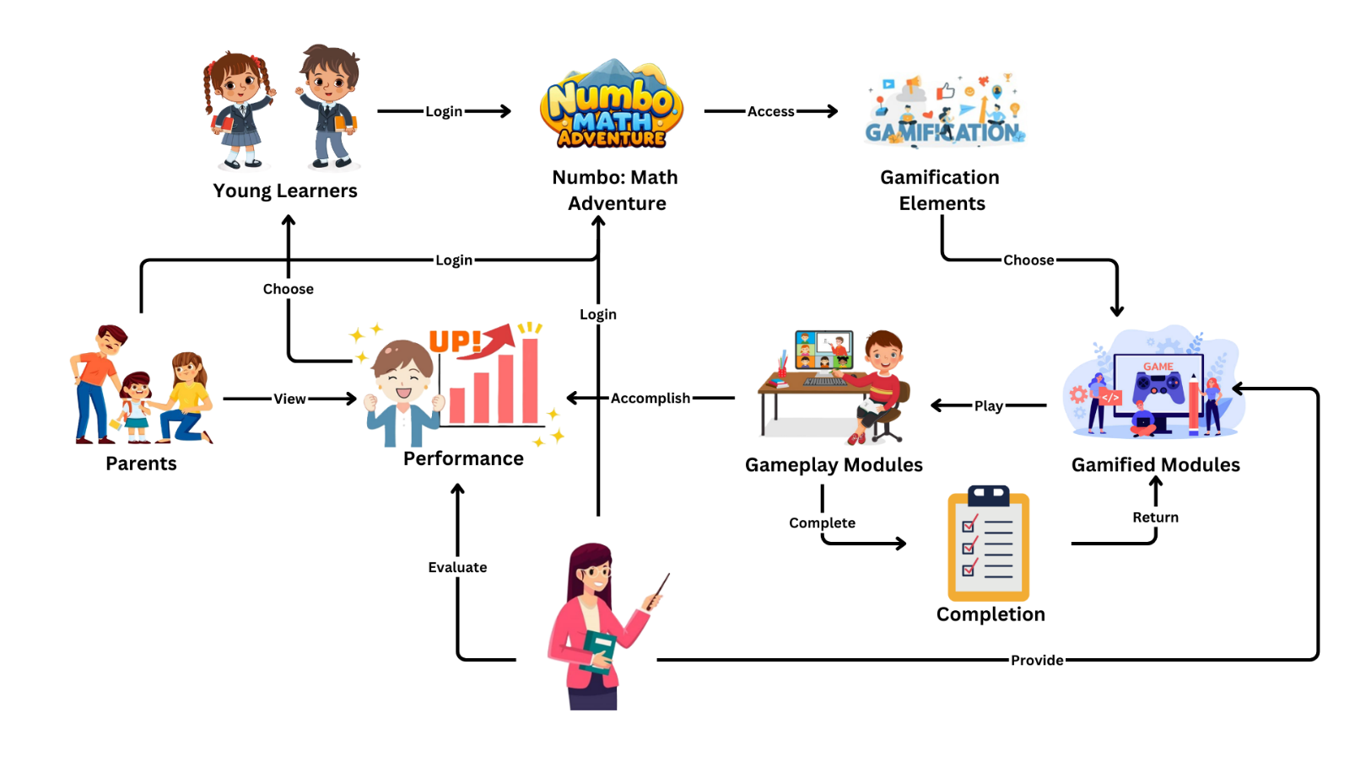**Conceptual Framework:**

## Figure 1.1. Research Paradigm

This figure illustrates the flow of a gamified mathematics learning web app, designed to enhance user engagement and learning outcomes in Grade 1 students at Jose Rizal University.

**1. Young Learners:**

* Students log in to the app to access the gamified learning environment.

**2. Numbo: Math Adventure:**

* Upon login, students, parents, and teachers can access the web-based platform featuring gamified elements.

**3. Gamification Elements:**

* **Progress Tracker:** Displays achievements, performance, and completion status of the students.
* **Practice Games:** Students are presented with practice games to enhance their learning.
* **Update Profile:** Allows students to update their profile information.

**4. Completion:**

* Upon completing a module or game session, students are given the option to:
  + **Return to Gamified Modules:** Explore other modules or topics.
  + **Retry Activities:** Retry activities or challenges to improve their scores and mastery.

**5. Teacher:**

* Teachers log in to provide support to students by monitoring their progress, offering guidance, and encouraging participation in challenges and activities to enhance learning outcomes.

**6. Parents:**

* Parents log in to provide support to students by monitoring their progress, offering guidance, and encouraging them to stay engaged in their learning.

**Significance of the Study**

The present study may be beneficial to the following:

* **Young Learners**: Grade 1 students will benefit from a more engaging and enjoyable learning experience through the web-based.
* **Teachers**: Educators can utilize the resources provided by the web-based development to ensure active participation and enjoyment among students during mathematics lessons.
* **Parents**: Parents will have access to resources that facilitate their children's learning at home, fostering a stronger connection between home and school.
* **Jose Rizal University Elementary Division**: The findings of this study can contribute to enhancing teaching practices within the university, thereby improving the quality of early childhood education.
* **Future** **Research**: This study can serve as a foundation for future research in the field of early childhood education, providing a framework for investigating various aspects of teaching and learning strategies for young children.
* **Researchers**: Researchers will gain insights into the effectiveness of gamification in early childhood education, providing a foundation for further studies on innovative teaching methods and their impact on young learners' academic performance and engagement.

**Scope and Limitations of the Study**

**Scope**: This study focuses on the development and evaluation of a Web-Based, titled "Numbo: Math Adventure" only designed for Grade 1 students at Jose Rizal University, specifically targeting the subject of Mathematics. The primary objective is to assess the effectiveness of gamified mathematics learning through the Web-based in enhancing students' interest, engagement, and performance in math-related topics aligned with the early childhood, including numeracy skills, basic arithmetic, and problem-solving.

**Limitation**: Despite its comprehensive approach to mathematics education, the web-based may not cover every aspect of the early childhood math modules due to resource and time constraints. Parental involvement in math education may vary, impacting the extent to which students utilize the web-app outside of school hours. While the study will adhere to ethical guidelines regarding participant consent and data privacy, it may not address every potential ethical concern, particularly regarding the involvement of young children in research studies. However, modifying the gamified elements may be challenging due to technical limitations and resource constraints in development.

**Definition of Terms**

* **Gamification:** The integration of game elements and mechanics into non-game contexts, such as educational activities, to increase engagement and motivation.
* **Numbo: Math Adventure**: The name of the web app developed for Grade 1 students at Jose Rizal University, aimed at enhancing mathematical learning through gamified activities.
* **Young Learners:** Refers to children in the early stages of education for Grade 1 students.
* **Jose Rizal University**: The school where this study takes place.
* **Learning Outcomes**: Getting better at math and having fun while they do it.
* **Math modules**: Different sections in the digital game that cover specific math topics.

**Chapter 2**

**Review of Related Literature**

This chapter presents both local and foreign literature concerning the utilization of web-based, given the prevalent proficiency many children today display with these devices over traditional literacy skills like reading and writing. Harnessing this familiarity could prove beneficial for learners, as they tend to be more enthusiastic about using web-based, facilitating quicker adaptation and fostering attachment to the web being developed by researchers. The primary objective is to enhance learning through playful engagement, achieved by integrating cartoon-style assets. These elements hold significant appeal for young children, enriching their overall learning experience. Importantly, there is a notable surge in the number of children using digital devices compared to previous years.

A goal of any educational measure is to improve students’ capability to retain teaching content. In this paper, we investigate the potential of gamification to foster knowledge retention using an action research approach. We present the results from a longitudinal study including 617 secondary and tertiary education students conducted over a period of two years. Various workshop designs that incorporated numerous gamification elements were compared with non-gamified workshop designs, tested and refined over time. The improved workshop designs led to increased levels of knowledge retention that exceeded the benchmark values from educational literature. We found that gamification exerts a positive impact on knowledge retention. We tested for the moderating effects of gender and age and found no effect of the former and inconsistent results for the latter. The steady increase in students’ learning performance resulting from constant refinement of the workshops demonstrates the usefulness of incorporating gamification principles into educational activities. (L.-M. Putz, F. Hofbauer, and H. Treiblmaier. Apr. 2020) [1].

Gamification teaches children many new abilities at a young age. It also increases their emotional well-being and emotional intelligence. Gamification enables your kid to study in a distraction-free atmosphere in a familiar setting. Gamification helps foster a positive attitude toward learning by creating engaging, personalized, and amusing learning materials. The majority of educational learning applications include unique music that will aid language development. Gamification allows your kid to study and participate at their own speed, free of peer or teacher pressure. (H. M. Lee and P. A. Loo, July. 2021) [2].

Teaching and learning in or outside of the classroom through computers and internet is called E-Learning. In the present era, technology-mediated learning approach has gained worldwide popularity from the educational standpoint. E- Learning is computer-based learning, and pedagogically, it is student cantered and collaborative learning. E-learning serves learning and teaching procedure through all electronic forms. The information and communication systems serve as definite media to carry out the learning process. A number of educational institutes in developing countries are still using old and conventional methods of learning. These types of methodologies follow traditional method of delivering lectures in classrooms. Since, several institutes have started blending learning, still a lot of them follow traditional procedures. Several epidemics outbroke and changed the whole picture of the world. The world of 21st century is now experiencing the same phenomenon in form of Covid-19. It is deadly disease spread by Corona Virus. It is declared as a pandemic by WHO. Every field of life is badly affected. This situation challenged the education system across the world and forced educators to switch to an online mode of teaching overnight. Face to face classes is banned to ensure the social distance. The educational institutes which were not ready to accept new method of teaching, they are left no choice except to change their methods and switch to online teaching and learning. The undertaken research explores the significance, advantages, disadvantages and benefits of E-Learning both for students and teachers (S. Akhter, M. K. Javed, S. Q. Shah, and A. Javaid, May. 2021) [3].

Gamified learning has emerged as an effective approach to improving students' engagement and academic performance in mathematics. The study by Santiago, Rodriguez, and Cruz (2024) introduced **MATHevation**, a gamified learning web application designed to enhance students' mathematical skills through an interactive reward-based system. Their findings indicate that incorporating game mechanics, such as point accumulation, achievement badges, and leaderboard rankings, fosters motivation and encourages active participation in learning activities. The study supports previous research on gamification in education, demonstrating that digital tools can positively impact students' problem-solving abilities and conceptual understanding. Moreover, the integration of a reward system helps reinforce positive learning behaviors, making mathematics more engaging and accessible. This research contributes to the growing literature on technology-enhanced learning, emphasizing the potential of gamification to bridge traditional and digital education methodologies effectively. (C. Santiago, J. Rodriguez, and M. Cruz, October 2024) [4].

In their 2024 literature review, Nob, Roble, and Lomibao examined the multifaceted effects of gamification in mathematics education within the Philippine context. Analyzing 31 selected studies, they identified several positive outcomes, including increased student engagement and motivation, improved academic performance, and enhanced higher-order thinking skills. Factors contributing to heightened engagement encompassed competitive learning environments, collaborative activities, reward systems, and interactive features within gamified interventions. The study also highlighted that feedback mechanisms and immersive elements in gamified learning environments played a significant role in bolstering students' academic achievements in mathematics. This comprehensive review underscores the potential of gamification as a transformative approach in mathematics education, particularly when thoughtfully integrated into the curriculum. (J. M. R. O. Nob, D. B. Roble, and L. S. Lomibao, July 2024) [5].

Bang, Li, and Flynn analyze the impact of early childhood educational interventions on student development. Their study investigates how early exposure to educational games and activities can influence cognitive and social development. The authors provide evidence that interactive and engaging educational tools can have a lasting positive impact on young children, helping them develop foundational skills in literacy, numeracy, and social interaction. They also discuss the importance of creating a stimulating and supportive learning environment that encourages exploration and curiosity. The research underscores the critical role of early education in shaping future academic and personal success (Bang, Li, and Flynn, April. 2022) [6].

Gamification in mathematics education has been increasingly explored as a strategy to enhance student engagement and motivation. Alt (2023) examined the impact of different gamification approaches on students' gameful experiences and gaming motivation in mathematics learning. The study compared problem-based and non-problem-based digital and face-to-face game-based learning activities among 779 students in Israeli public schools. Findings indicated that problem-based digital gamification significantly improved students' motivation and engagement compared to other approaches, highlighting the importance of integrating problem-solving elements within gamified learning environments. This aligns with previous research emphasizing the role of well-structured gamification in fostering a positive learning experience. The study contributes to the growing body of literature supporting the effectiveness of digital gamification in mathematics education, reinforcing its potential in enhancing student learning outcomes. (D. Alt, July. 2023) [7].

Gamification in educational settings is explored in depth by McCarthy, who defines it as the integration of game elements, such as point scoring, leaderboards, and badges, into non-game environments to enhance engagement and motivation. He argues that gamification can transform passive learning environments into active and dynamic ones. By implementing gamification strategies, educators can foster a more engaging and interactive learning experience, which can lead to improved student outcomes. The article provides several examples of successful gamification in classrooms, demonstrating its potential to make learning more enjoyable and effective (McCarthy, Dec. 2021) [8].

Gamification in e-learning environments has been widely studied as a strategy to enhance student engagement and motivation. Imran (2019) investigated the effectiveness of awarding badges in gamified e-learning systems and their impact on student participation and motivation. The study, published in Smart Learning Environments, highlights how badges serve as visual representations of achievements, encouraging students to complete tasks and engage with course materials. Findings suggest that badges provide extrinsic motivation, reinforcing students' sense of accomplishment and recognition. The research emphasizes that well-designed gamification elements, such as achievement-based rewards, can positively influence learning behaviors. This aligns with previous studies advocating for the integration of gamification in digital learning platforms to foster engagement and improve educational outcomes. (H. Imran. Dec. 2019) [9]

Best investigates the value of games in mathematics education, positing that games can serve as powerful educational tools by making abstract mathematical concepts more concrete and understandable. According to him, games encourage active participation and critical thinking, which are essential for mastering mathematical skills. The article highlights several studies that support the use of educational games to improve problem-solving abilities and mathematical reasoning. Best also provides practical tips for educators on how to integrate games into their math curriculum, suggesting that a balanced approach can help maintain student interest and motivation (J. Best, 2019) [10].

The benefits of collaborative learning facilitated by digital platforms are explored by Zamzami et al. Their research examines how digital tools can enhance collaboration among students, particularly in higher education settings. They discuss the advantages of using platforms like online discussion forums, collaborative documents, and virtual classrooms to foster communication and teamwork. Their study finds that such tools not only improve academic performance but also help students develop important skills like critical thinking and problem-solving. The research concludes that digital collaboration can create a more inclusive and supportive learning environment, particularly for students who may struggle with traditional classroom dynamics (Zamzami et al., 2020) [11].

Educators are always looking for ways to improve engagement in the classroom. Traditional approaches to math education are being phased out, amid declining student achievement in mathematics, and replaced with innovations like gamified learning. Gamified learning supplements instruction and curriculum by providing a fun environment, ensconced in virtual and augmented reality, for students to interact with the content. Voigt [12] examined the efficacy of gamified learning in mathematics with respect to motivation and student achievement. Studies in which researchers created and tested new math games have been evaluated to answer the guiding research question. Self-determination Theory, a theory about human motivation, is unpacked and used as a framework that helps educators generalize the conclusions to the classroom. The results showed gamified learning to be a competent tool for increasing motivation and student achievement in the short term, but more longitudinal studies are needed to verify such gains can be sustained over the span of a course. (N. M. Voigt, 2023) [12].

The integration of digital learning tools in early childhood education has become increasingly significant, especially in the context of remote learning necessitated by global events such as the COVID-19 pandemic. Research indicates that interactive, game-based applications can effectively enhance young children's cognitive abilities, particularly in foundational subjects like mathematics. For instance, the development of EduGame Maru, an Android-based or Web-based application, aims to teach early mathematical concepts to children aged 4-6 years through engaging activities aligned with the National Council of Teachers of Mathematics (NCTM) principles. Studies have demonstrated that such applications are not only feasible and practical but also serve as valuable tools for teachers and parents to optimize cognitive development during online learning periods. (R. D. Widjayatri et al. Apr. 2022) [13]

Gamification has been increasingly integrated into educational settings to enhance student motivation and engagement, particularly in mathematics. Jagušt et al [14]. (2017) conducted a study on the effects of gamified digital math lessons for lower primary school students, involving 59 second and third-grade students in Croatia. The study implemented gamification elements in digital learning activities using tablet computers, aiming to improve students’ interest in mathematics. The findings revealed that gamified digital lessons significantly increased students’ engagement compared to traditional, non-gamified approaches. This supports the idea that game-based learning can enhance students’ motivation, making mathematical concepts more interactive and enjoyable. Furthermore, the study highlights the potential of digital gamification in sustaining student attention and improving learning outcomes in early mathematics education.

The study emphasizes the importance of numeracy skills for elementary students, which are crucial not only for academic success but also for real-life decision-making in areas such as health and finance. Traditional teaching methods, which often rely on rote learning and teacher-centered approaches, are less effective for fostering numeracy skills. These methods fail to engage students, particularly those with learning difficulties, leading to the need for innovative teaching strategies that focus on student-centered and interactive learning techniques. Educational games have emerged as an effective alternative to traditional methods, offering a dynamic way to engage students in developing numeracy skills. By incorporating game-based learning, teachers can create an environment where students actively participate and construct knowledge through hands-on experiences. This approach not only enhances students' understanding of mathematical concepts but also fosters a positive attitude toward learning, helping them build confidence and perseverance in solving mathematical challenges. The study highlights the potential of educational games to support numeracy development, particularly for primary school students in the Philippines, who face challenges in acquiring these essential skills due to factors like inadequate educational opportunities and curriculum congestion. (M.-A. D. Abbacan, J. P. Lasangen et al. Jan 2025 [15]

The study investigates the development of a web-based realistic mathematics learning environment aimed at enhancing 21st-century skills for primary school students. This research applies the PMRI (Pendidikan Matematika Realistik Indonesia) approach with a focus on the cultural context of Sumatera. It emphasizes the use of digital tools such as MOODLE and Google Sites to create an engaging, interactive learning platform that aligns with modern educational practices and technology integration. By adopting the Kirkpatrick model for evaluation, the study measures the effectiveness of this approach in fostering creativity, problem-solving, and critical thinking among students, essential skills for their future challenges. The findings suggest significant improvements in students' mathematical understanding and their ability to apply concepts in real-world scenarios, reinforcing the importance of integrating culture and technology in educational environments. (L. Lisnani, R. I. I. Putri, et al. March 2023) [16].

|  |  |  |  |  |  |
| --- | --- | --- | --- | --- | --- |
| **Title** | **Author** | **Date** | **Key Findings** | **Key Gaps** | **Present Study** |
| **Can** gamification help to improve education? Findings from a longitudinal study | L.-M. Putz, F. Hofbauer, and H. Treiblmaier. | Apr. 2020 | - Gamification enhances engagement and motivation. - Longitudinal results show improved retention. | - Lack of focus on specific learning outcomes. - Limited data on long-term impact. | This study explores how gamification impacts student motivation and performance, focusing on specific learning metrics. |
| **Gamification** of Learning in Early Age Education | H. M. Lee and P. A. Loo | July 29, 2021 | - Gamification helps children develop cognitive skills. - Enhances emotional well-being and intelligence. - Encourages a positive attitude toward learning. | - Limited empirical data on long-term benefits. - Need for studies in diverse educational settings. | This research expands on gamification's role in early education by measuring its effectiveness across different student demographics. |
| **Highlighting** the Advantages and Disadvantages of E-Learning | S. Akhter, M. K. Javed, S. Q. Shah, and A. Javaid | May 2021 | - E-Learning offers flexibility and accessibility. - Promotes student-centered and collaborative learning. | - Challenges include lack of face-to-face interaction. - Dependence on technology and internet access. | This study integrates gamification into e-learning models to address engagement and motivation challenges. |
| **MATHevation:** Enhancing Student Academic Performances in Mathematics Through a Gamified Learning Web Application with reward System | C. Santiago, J. Rodriguez, and M. Cruz. | October 2024 | A gamified web app improved students’ math performance through interactive activities and rewards. | Study was limited to one school and did not assess long-term effects. Further research is needed in diverse settings. | Supports the effectiveness of gamified learning in improving students' math achievement.  Examines gamified learning for Grade 1 students, adapting content for early math skills. |
| **Unveiling** the Effects of Gamification on Math Learning: A Literature Review in the Philippine Context | . M. R. O. Nob, D. B. Roble, and L. S. Lomibao | July 2024 | Gamification improves engagement, motivation, and math performance in the Philippines. | Limited to existing studies; lacks empirical data from new interventions. Further research needed to explore long-term effects and applicability across diverse educational settings. | Provides a comprehensive synthesis of gamification's impact on math learning in the Philippines, informing future educational strategies and research directions. |
| **Efficacy** of an Adaptive Game-Based Math Learning App to Support Personalized Learning and Improve Early Elementary School Students’ s Learning | H. J. Bang, L. Li, and K. Flynn | 2022 | Evaluates app's effectiveness in supporting personalized learning and improving outcomes for early elementary students. | Potential lack of specificity regarding the app's adaptation to diverse learning contexts. | Adapting math app to suit various early elementary education settings. |
| **Assessing** the Benefits of Gamification in Mathematics for Student Gameful Experience and Gaming Motivation | D. Alt | 2023 | Assesses gamification's impact on student motivation and engagement in math. | Limited exploration of gamification's effectiveness specifically for younger learners. | Investigating efficacy of gamified math app for early elementary students. |
| **Using** Gamification to Ignite Student Learning | J. McCarthy | Dec. 2021 | Gamification enhances student engagement by using rewards, badges, and achievements to motivate learning. It encourages intrinsic motivation and deeper content mastery through structured, noncompetitive play. | The article provides practical strategies but lacks empirical data on long-term effectiveness. More research is needed on its impact across different subjects and student demographics. | Offers insights on using gamification to improve student motivation and engagement, informing best practices for educators. |
| **Evaluation** of Awarding Badges on Student’s Engagement in Gamified e-learning Systems | H. Imran | 2019 | Investigates badges' positive impact on student engagement within gamified systems. | Applicability of findings to a math app context is uncertain. | Examining how badges affect engagement in math app usage. |
| **The** Value of Games and Gamification with Mathematics | J. Best | 2019 | Highlights the value of integrating games to improve math understanding. | General focus, may not specifically address needs of young learners. | Investigating value of games in gamified math learning for children. |
| **The** Impact of Gamification on Learning and Instruction: A Systematic Review of EmpiricalEvidence | Z. Zamzami, S. K. W. C., M. Shujahat, and C. J. P. | June. 2020 | Reviews empirical evidence on gamification's impact on learning broadly. | May lack direct examination of gamification's effects on young students. | Applying systematic review findings to a math app context for children. |
| **Gamified** Learning in Math Education | N. M. Voigt | 2023 | Gamified learning environments, incorporating virtual and augmented reality, can enhance student motivation and achievement in mathematics. | Existing studies demonstrate short-term benefits; however, longitudinal research is needed to assess sustained impacts over an entire course duration. | This study evaluates the efficacy of gamified learning in math education, utilizing Self-Determination Theory to analyze its effects on student engagement and performance. |
| **EduGame Maru**: Application for Early Mathematics Learning as an Alternative for Optimizing Cognitive Ability for 4-6 Years Children | Rr. Deni Widjayatri et al. | April 2022 | EduGame Maru, designed for children aged 4-6, effectively enhances early math learning through interactive games based on NCTM principles. Validation and teacher assessments rated it highly for feasibility and effectiveness. | Focused on short-term usability; lacks long-term studies on cognitive development and broader implementation. | Supports interactive, game-based learning for early childhood math education, offering a practical tool for teachers and parents. |
| **Gamified** Digital Math Lessons for Lower Primary School Students | T. Jagušt, I. Boticki, V. Mornar, and H.-J. So | July 2017 | Implementing gamification in digital math lessons for second and third graders in Croatia enhanced student motivation and engagement. Gamified activities sustained higher interest levels compared to non-gamified approaches. | The study focused on short-term engagement; long-term effects on learning outcomes were not assessed. Further research is needed to evaluate sustained impact and applicability across diverse educational settings. | This research supports the use of gamified digital lessons to boost motivation and engagement in early mathematics education, providing insights for educators on effective instructional design. |
| **Exploring** the Impact of Educational Games on Numeracy Skill Development Among Elementary Learners: A Systematic Review | M. D. Abbacan et al. | Jan. 2025 | Educational games enhance numeracy skills by increasing engagement and motivation among elementary learners. They offer interactive and personalized learning experiences that traditional methods may lack. | Limited empirical evidence on long-term effectiveness and applicability across diverse educational settings. Further research is needed to assess sustained impact and generalizability. | This systematic review synthesizes existing studies to inform future educational strategies and research directions in the Philippines. |
| **Web-based** Realistic Mathematics Learning Environment for 21st-Century Skills in Primary School Students | Lisnani, Ratu Ilma Indra Putri, Zulkardi, Somakim | March 2023 | A web-based math learning tool was developed using cultural themes from Sumatera Island, which helped improve math learning and promoted 21st-century skills in primary students. | The study didn't evaluate long-term impacts on students' math skills or skill development. | Supports the use of culturally relevant web-based tools to improve math education and essential skills in primary school students. |

**Chapter 3**

**METHODOLOGY**

**Research Design**

This study will use a mixed-methods research design to investigate the effectiveness of gamified mathematics learning through a web app for Grade 1 students at Jose Rizal University. By combining qualitative and quantitative methods, the research aims to gather diverse and detailed data, offering deeper insights into the research questions.

Interviews will be conducted with faculty members to identify challenging math topics based on module and student performance data. Additionally, faculty members will provide feedback on the proposed gamified mathematics learning web app, offering valuable insights into its potential strengths and areas for improvement.

Grade 1 students will participate in focus group discussions to explore their perspectives on mathematics, digital learning, and gamification. These discussions will enable students to share their thoughts on challenging topics and their preferences regarding app features, aiding in understanding how they perceive learning through gamified methods.

Surveys will be distributed to students, teachers, and parents to gather feedback on the gamified mathematics learning experience. These surveys will evaluate aspects such as engagement, enjoyment, learning outcomes, and usability of the web app. Analyzing survey responses quantitatively will help identify trends and patterns in how participants view and feel about the gamified method of teaching math.

## This study plans to use both qualitative and quantitative methods to gather information from making the results more reliable. The qualitative part will give us detailed insights, while the quantitative part will give us statistical evidence to show how well the game helps with math. Overall, this research will help us understand how "Numbo: Math Adventure" affects young learners math learning at Jose Rizal University.

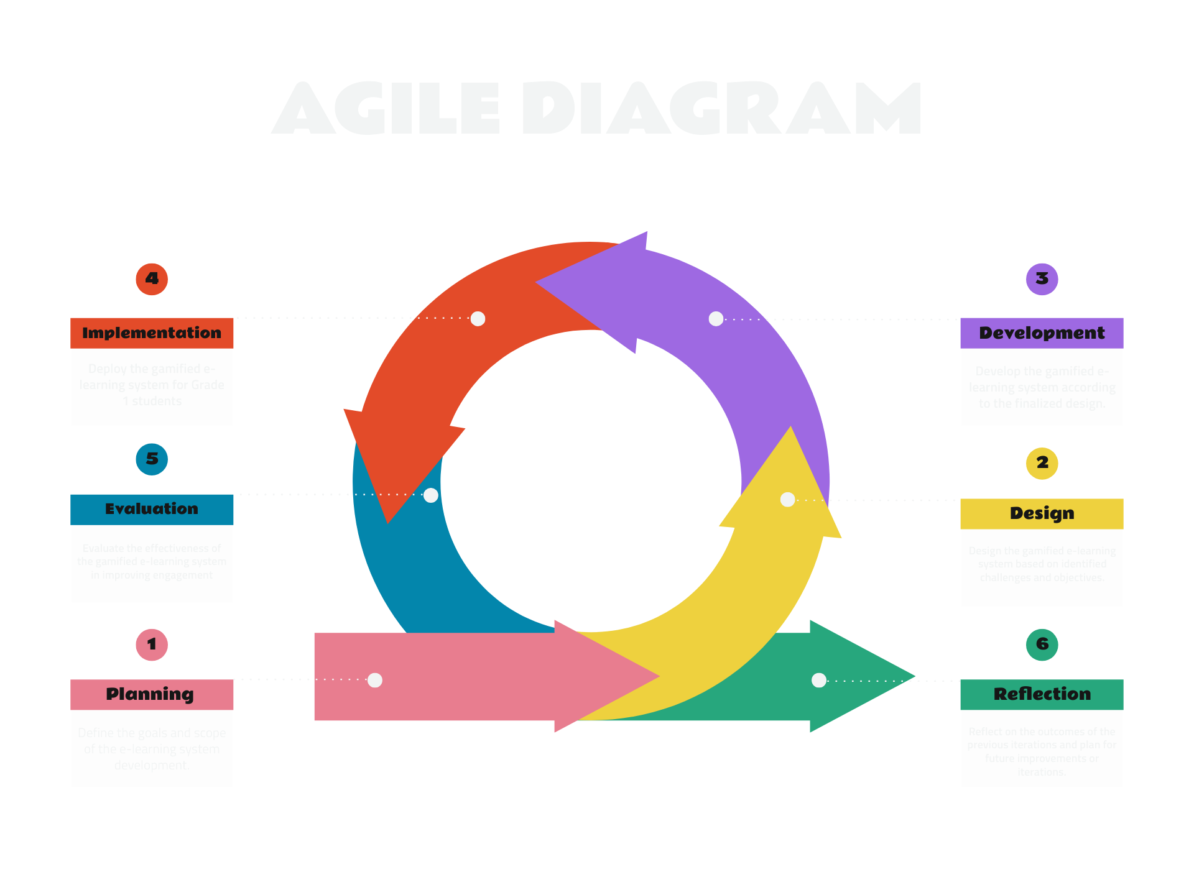

## Figure 3.1. Stages/Phases of Developing a Web App for Gamified Mathematics Learning for Grade 1 Students at Jose Rizal University.

## **Population and Sample**

The respondents of this study will involve Grade 1 students, faculty members, and parents from the elementary division of Jose Rizal University. The Grade 1 students come from various academic abilities, backgrounds, and demographics enrolled in the institution for the academic year. Faculty members are also part of the study since they play a vital role in teaching Grade 1 students. Furthermore, parents or guardians of Grade 1 students are included in the study, as they have a significant impact on their children's education.

For the sample, the researchers will choose at least five Grade 1 students from different classes or sections. Faculty members will be interviewed, particularly those who have taught Grade 1 students in math. Parents will be informed through email, letters, or parent-teacher meetings.

**Table 3.1 Target Respondents**

|  |  |  |
| --- | --- | --- |
| **Respondents** | **Total Number of Respondents** | **Target Respondents** |
| Grade 1 Students | 5 | 5 |
| Faculty Members | 3 | 3 |
| Parents/Guardians | 5 | 5 |
| Total | | 13 |

## **Research Locale**

The Elementary Division of Jose Rizal University was selected as the study site due to its accessibility, which allows a diverse group of Grade 1 students to participate. Collaborating with JRU's faculty members fosters a supportive environment for implementing and evaluating the Web-based for gamified mathematics learning. Conducting the study locally ensures that findings can directly influence educational practices and policies within the community. By addressing the specific needs of JRU's Grade 1 students, this project can serve as a model for other schools in the region. Given our familiarity with JRU, we can plan the intervention more effectively and address ethical issues appropriately. In summary, JRU provides an ideal setting for this research, offering the potential to enhance mathematics teaching in elementary schools.

<https://jru.edu/campus-map/>

**Method or Procedure**

**Proposal Approval:** The study proposal titled "Gamified Mathematics Learning through a Web Development for Grade 1 Student at Jose Rizal University.” will be submitted to the academic advisor for approval.

**Literature Review:** Our literature review will gather relevant studies, theories, and methodologies related to gamification learning for primary education, particularly focusing on mathematics education and gamification strategies. This research study seeks to understand how gamified learning platforms can enhance the mathematical learning experience for young learners.

**Research Design:** The study approach will be settled upon, containing a combination of techniques that includes observation, interviews, and usability testing. Research instruments such as survey questionnaires and interviews will be used to gather insights from both students and teachers. Additionally, direct observation of classroom activities and interactions will be conducted to assess usability and effectiveness.

**Instrument Preparation**: Surveys and interview protocols will be created to gather information about students' engagement with mathematics, their preferences for learning methods, and their experiences with the web app. These instruments will also aim to gather feedback from teachers regarding the effectiveness of the gamified mathematics learning in Grade 1 math.

**Data collection:** Data collection includes conducting surveys and interviews with Grade 1 students and teachers at Jose Rizal University.

**Data Analysis:** Data from surveys and interviews will be analyzed to identify patterns and themes related to students' engagement, learning outcomes, and user experience with the web-based. The analysis will provide qualitative insights into the effectiveness of gamification in enhancing mathematical learning for Grade 1 students.

**Instruments**

**Survey:** Utilizing a survey to gather key information from Grade 1 students at Jose Rizal University about their attitudes towards learning mathematics, their familiarity with digital technologies, and their preferences for interactive learning activities. This survey will provide insights into students' readiness for engaging with gamified mathematics learning through a web-based.

**Interview:** These interviews aim to identify challenging math topics, gather feedback on the proposed gamified mathematics learning web app, and explore students' views on mathematics, digital learning, and gamification.

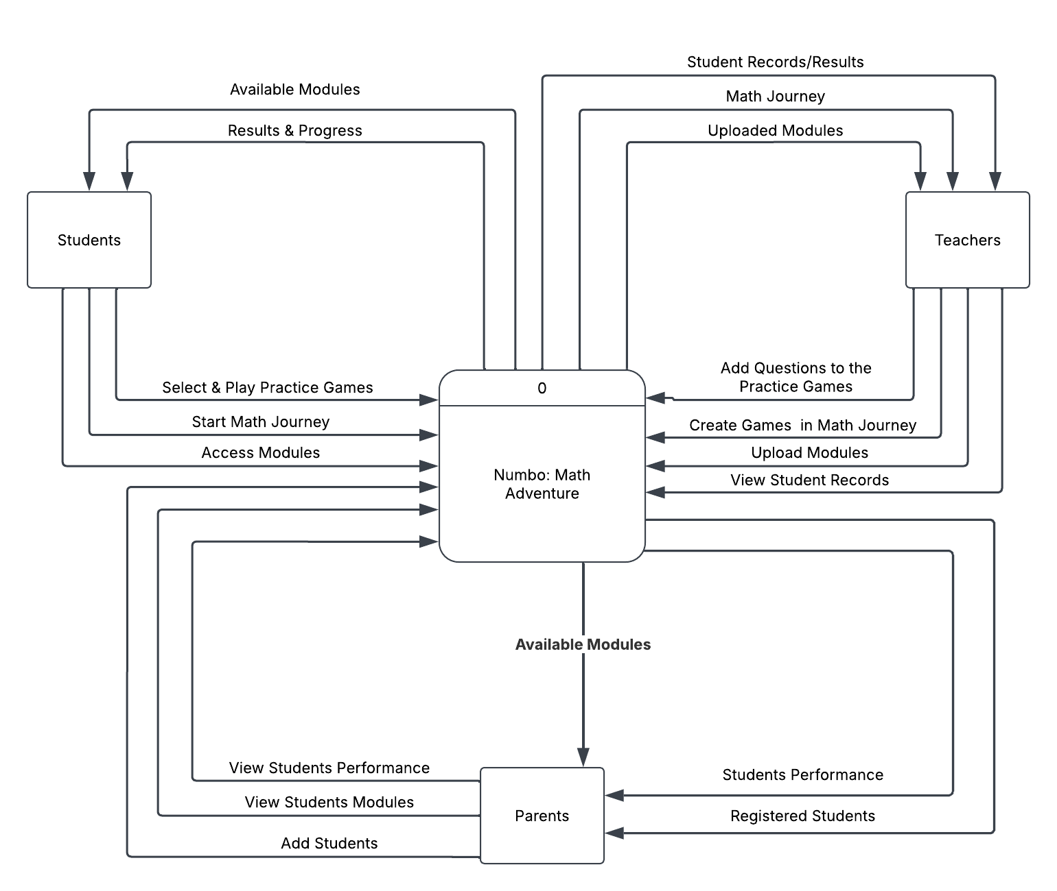

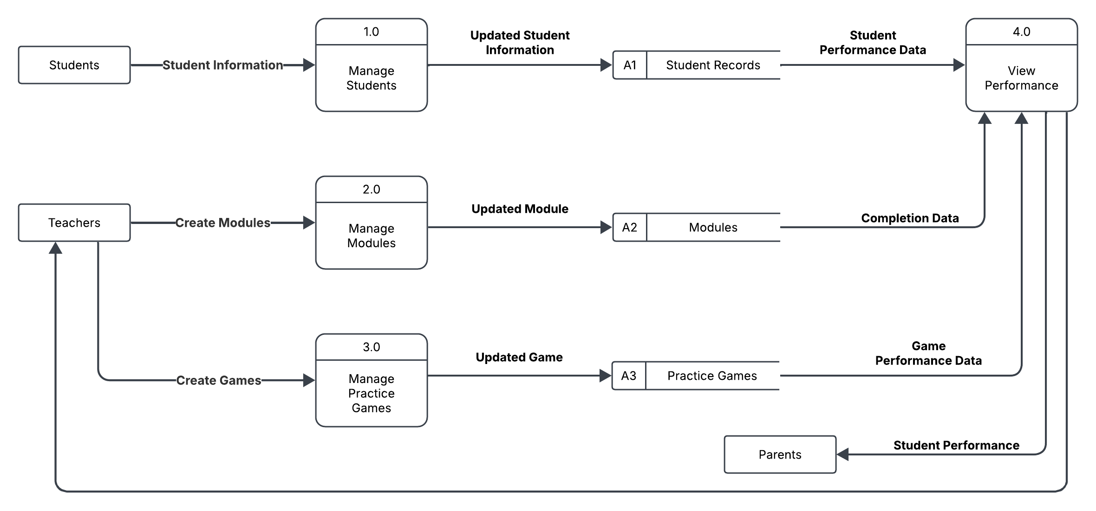

**Figure 3.2: Diagram displaying the data flowing in our Gamified Mathematics Learning**

This figure illustrates the interconnected processes and entities involved in implementing a web-app for Gamified Mathematics Learning through a Web Development for Grade 1 Student at Jose Rizal University, providing foundational guidelines for designing the web-app. Faculty members, as key implementers, utilize these standards to integrate gamification principles into the Modules, ensuring interactive and engaging learning experiences.

It begins with Grade 1 students, the primary beneficiaries of the Web-app. their engagement generates valuable assessment data, offering insights into their learning progress and outcomes. Additionally, both students and their parents/guardians contribute to the evaluation process through survey responses.

**Flowchart**

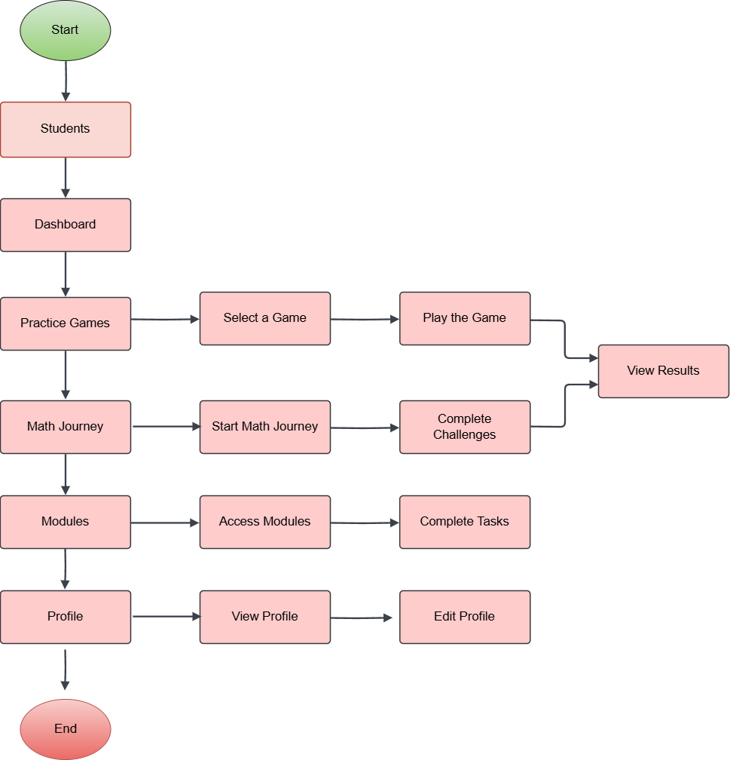

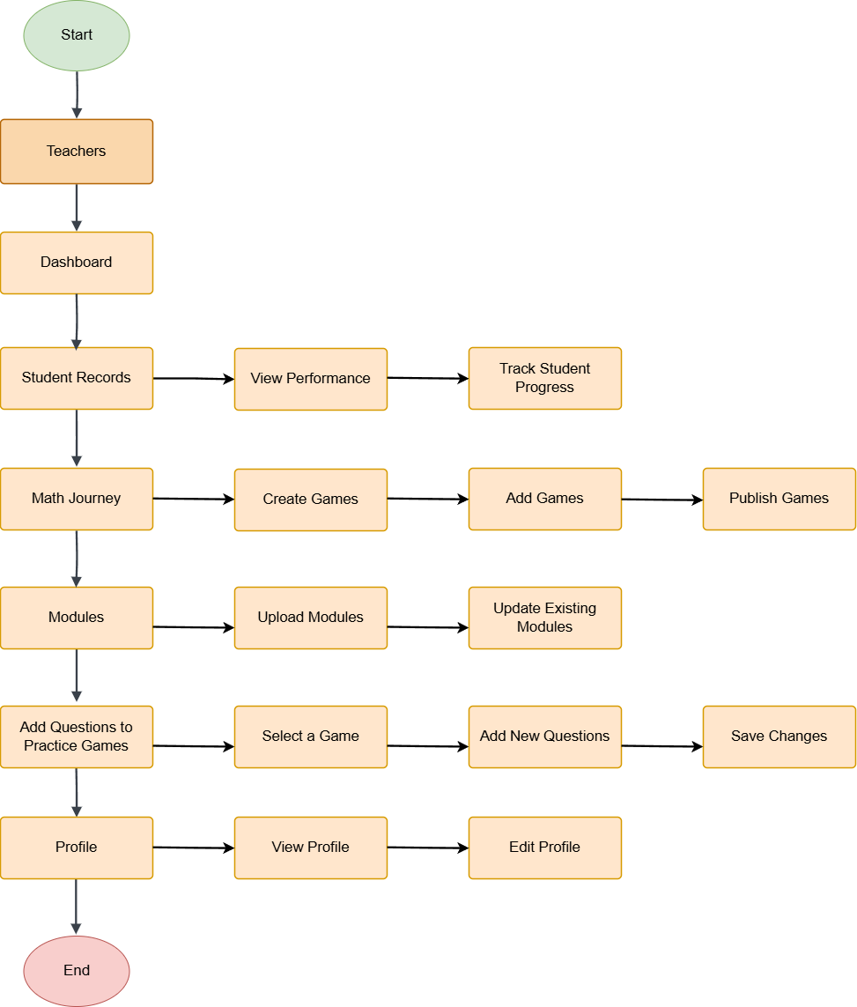

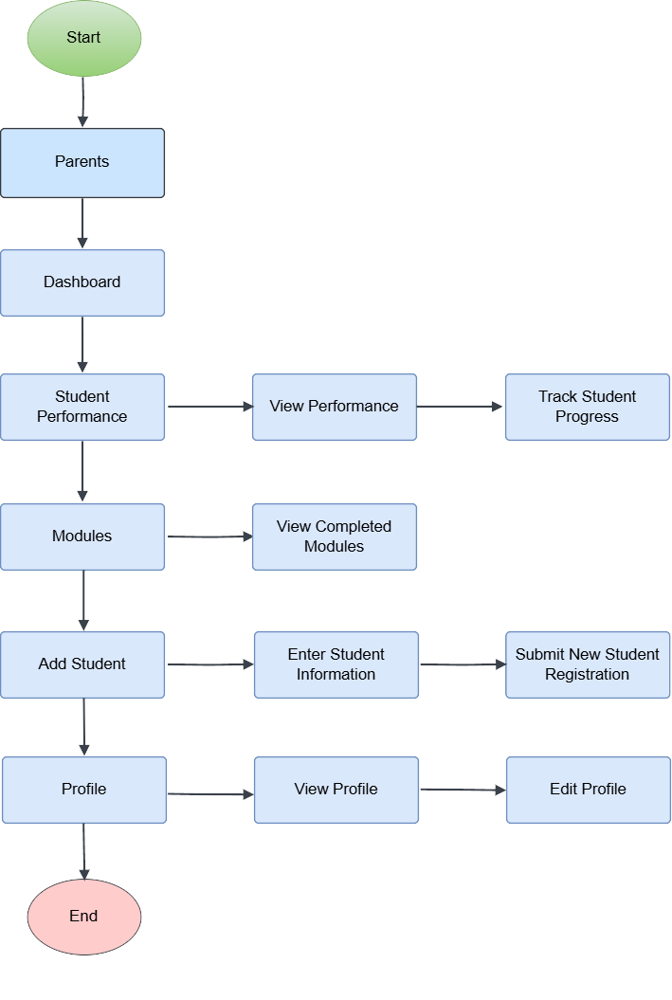

**Likert Scale:**

The purpose of this Likert scale is to assess the quality and efficacy of Gamified Mathematics Learning through a Web Development for Grade 1 Student at Jose Rizal University. Respondents are asked to rate their agreement with each statement on a scale of 1 to 5, and their responses will be helpful in identifying the strengths and areas for improvement in the research experience.

|  |  |  |  |
| --- | --- | --- | --- |
| Scale | Weight | Mean Range | Verbal Interpretation |
| 5 | Strongly Agree | 4.50 - 5.00 | Excellent |
| 4 | Agree | 3.50 - 4.49 | Very Good |
| 3 | Neutral | 2.50 - 3.49 | Good |
| 2 | Disagree | 1.50 - 2.49 | Fair |
| 1 | Strongly Disagree | 1.00 - 1.49 | Poor |

**Statistical Treatment**

The statistical treatment for the study of gamified mathematics learning through a web-based for Grade 1 students at Jose Rizal University involves a comprehensive analysis to determine the effectiveness of the web app. Initially, a sample of Grade 1 students using random sampling will ensure representativeness. The study will employ a pre-test and post-test design, where students' math skills will be assessed before and after the implementation of the web app.

Descriptive statistics, including mean, median, mode, standard deviation, and variance, will summarize the pre-test and post-test scores, providing a clear picture of the central tendency and dispersion of the data. To test the hypothesis that the web app improves math skills, a paired t-test will compare the mean scores of the pre-test and post-test, determining if the observed differences are statistically significant.

Results will be presented through tables and graphs, providing a visual representation of the data and facilitating interpretation. Statistical significance will be reported using p-values, with a threshold of p < 0.05 considered significant. The findings will be interpreted to assess whether the gamified mathematics learning web app has a meaningful impact on students' math skills, with implications for educational practices and recommendations for further implementation.